PROCESS DESCRIPTION – VERSION 4.0 (JUNE 2010)
ROLES: EVALUATORS / PROGR MANAGERS / SENIOR STAFF | PROCESS 5.3.0: GENERATING AGGREGATED REPORTS IN eIMS

# | Step | Observations | Menu options or screen information
0 | Producing aggregated reports in eIMS with data imported from OpenEMR allows managers, evaluators and senior staff to review clinic performance and participate in data quality assurance.  Preliminary steps:  Before generating reports in eIMS based on imported clinic files you have to Generate the necessary export files in OpenEMR [See Process Guideline 5.1.0] and import those files into eIMS [See Process Guidelines 5.2.0]. | Main Reports available are:  - Services by Age Group and Sex  - Aggregated service data using IPPF Service Statistics definitions by age group or sex  - Income by Services  - Monthly comparison of income by clinic  - Complications and procedures  - Monthly comparison of GCAC-relevant data (eg. Client status, Abo procedures, etc.)  - Unique Clients  - Monthly comparison of clients by clinic. Includes graphic totals  - Export of monthly service and client data | eIMS OpenEMR Menu  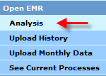  Reports currently available  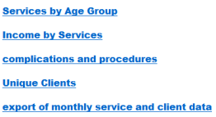
1 | Services by Age Group and Sex  eIMS allows the sequential definition of report parameters as follows:  Selecting Region and Member Association  Select report parameters, starting with the Region, and then the MA. You must follow the correct order to enable de corresponding parameters (i.e Region first, then the MA). | Selecting Region  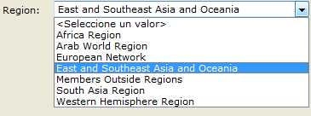 | Selecting Member Association  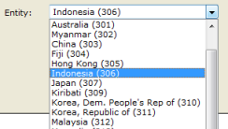
2 | Selecting Clinic(s) and Date Range  Select one clinic or a group of clinics from the drop-down menu by marking the corresponding tick boxes. Then you can specify the date range by typing the date directly or using the calendar function (as shown) | Selecting clinic(s)  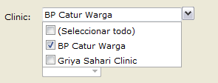 | Selecting date range  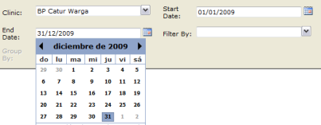
4 | Selecting Unit of Measure filter & grouping criterion  Select filter to report by services, products or referrals, or select all units of measure together. Finally, select the grouping criterion by age group, adult vs young people, and/or sex. | Selecting unit of measure filter  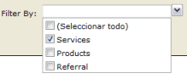 | Selecting grouping criterion  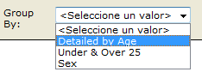
5 | View / Export / Print Report (Services by Age)  Example: Two-clinic aggregated data from Jun-Nov 2009, by services and detailed by age group  This report can be produced by sex
  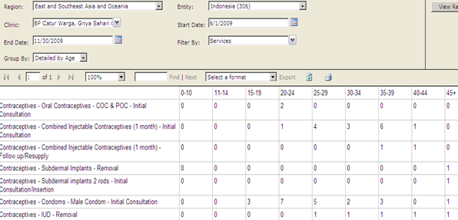 | Note: For this and all other reports described in this Guide, you can produce and save a printable report by selecting a format (PDF, Excel, etc.) and the Export link
6 | View / Export / Financial details by services  Example: Six-clinic aggregated income data (in US$ or Local Currency) from Dec 2009 to May 2010 | 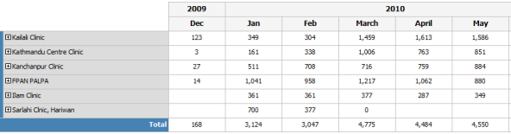
7 | View / Export / Complications & Procedures Report  Example: One-clinic monthly Abortion-related data, including Client Status, type of induced abortion, place of service provision, etc. | 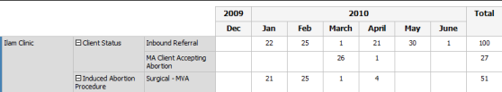
8 | View / Export / Unique Client (Table & Graph)  Example: Number of clients in six clinics from Dec 2009 to May 2010. A graph is included  Note: The term 'Unique clients' means that persons receiving services are counted only once
  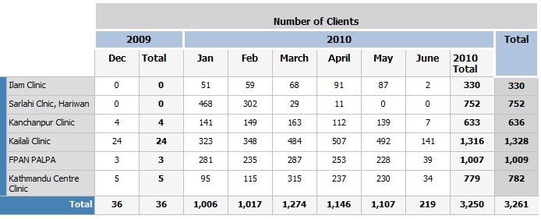 | 